**AIM:**

Write a C program to find Factorial of a given number without using Recursion

**ALGORITHM**

• **Start**

• Read the value of n.

• Initialize:

* first = 0
* second = 1

• Print first and second as the first two terms.

• Repeat for i = 3 to n:

* next = first + second
* Print next
* Update first = second, second = next

• **Stop**

**CODE**

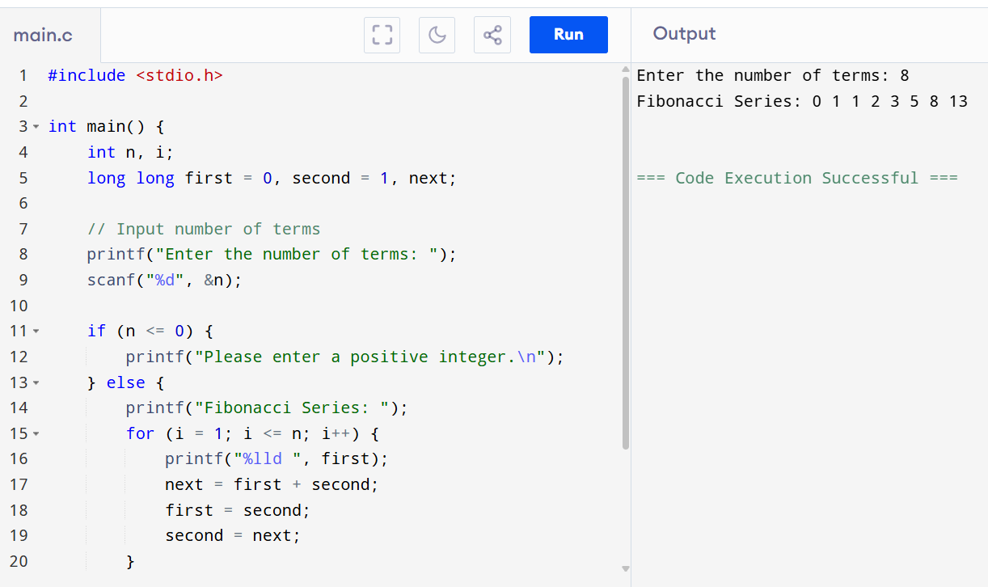

**OUTPUT**

Enter the number of terms: 8

Fibonacci Series: 0 1 1 2 3 5 8 13